# What is Angular?

Angular is a frontend JS framework it helps with building interactive modern web user interfaces

it's also a collection of tools and features (CLI, debugging tools, IDE plugins)

# Create Angular App

First steps is installed Angular CLI in computer by this command for version 17

npm install -g @angular/cli@17 ( you should have NodeJs)

Then for create new project:

ng new name_of_project (choose CSS and ‘no’ for server rendering)

in extensions Install angular language service – Angular essentials

npm start for run application

# Angular Essentials

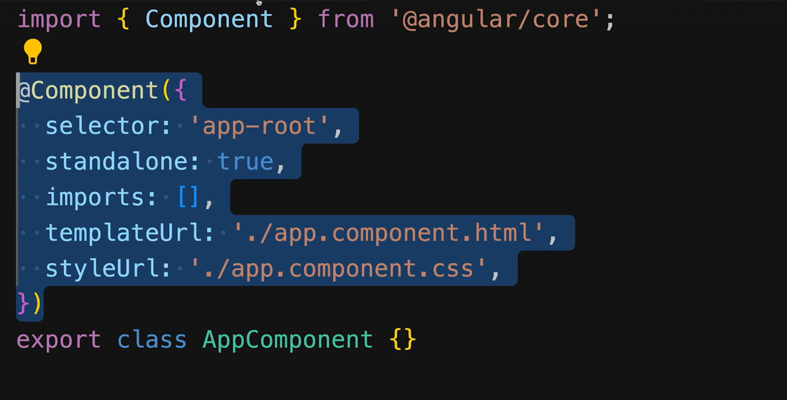

AppComponent is the component that call by bootstrapApplication and this not a normal class because it use @Component that called also a decorator that came from angular core

Selector is used to call to angular name of HTML markup that will be use in this case <app-root></app-root> that apply templateUrl to render into it place

To add component to other component we need to add this section

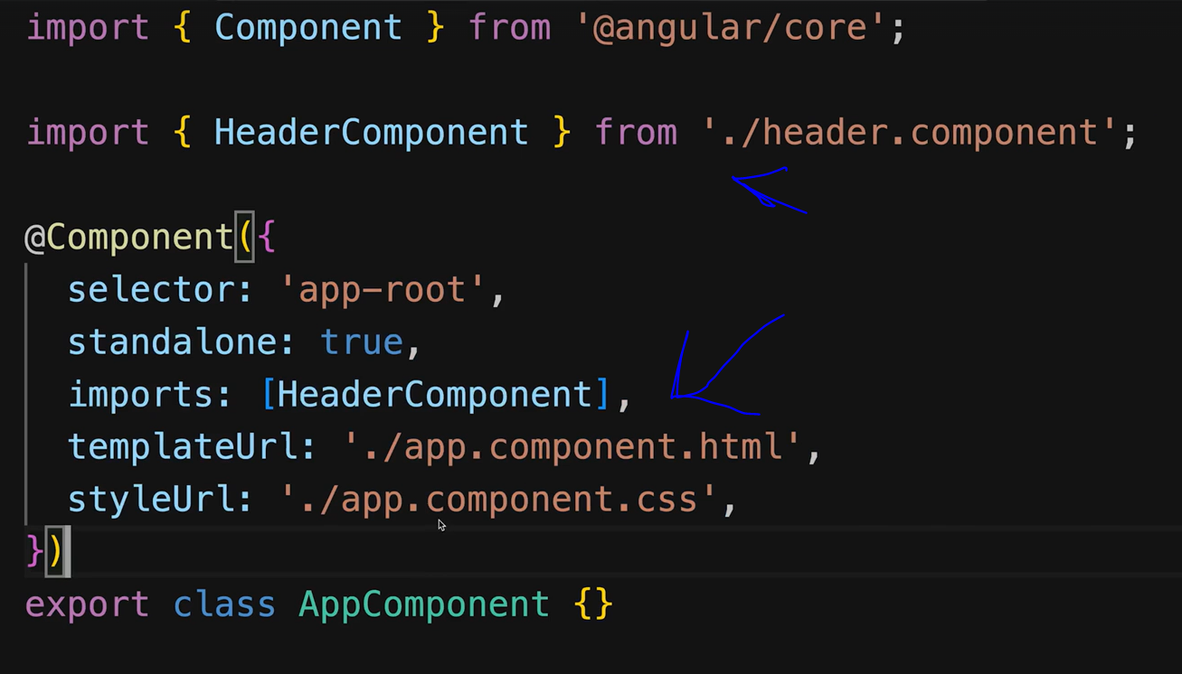

Now if you add selector of headerComponent inside app.component.html angular will recognize it

To generate a new component you need to tap in terminal ng g c nameOfComponent

Example

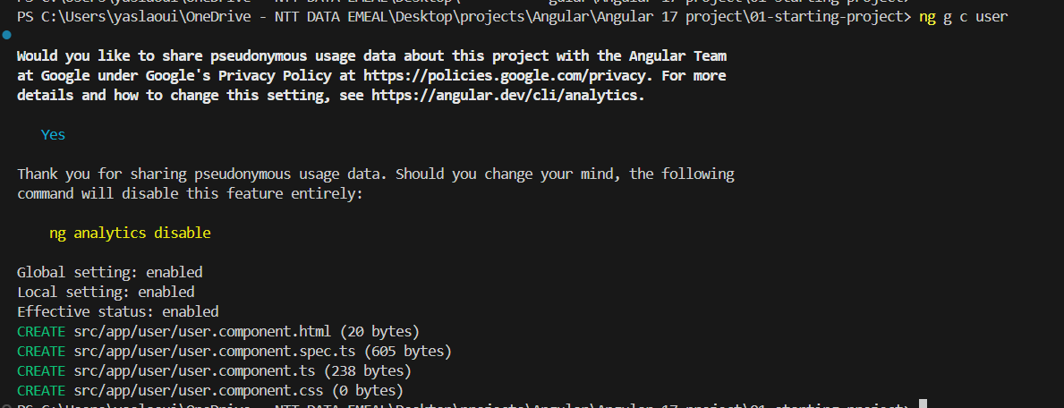

Data binding in angular is one most important thing and this an example how to output data from ts variable to HTML and also how to using in markup attribute that call property binder

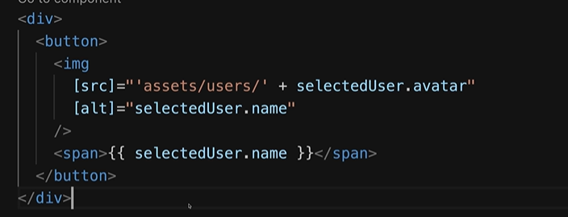

Signals : is a replacement of normal state It added in Angular core in version 16

Normal state use zone.js for detect any changes problem zone.js need to detect all the components but signals are trackable data container that angular manages subscriptions to the signal to get notified about value changes

If we use signal for example test = signal (value) to call it in template you need to call it like a function this.test().attr and for modify this.test.set(newValue) is new concept and generally isn’t use a lot yet

Component Input : is a decorator of angular core the make property(variable) settable from outside

That mean can get or change from other component let said that we have user component that have in selector user-app we can call it like that <user-app [inputParameter] = value/> and inside class user we add @Input({required:true}) inputParameter! :string; ! mean can be not initialize and required mean will appear error if you don’t use inputParameter like property when you call component

We can also use signals Input that give inputParameter type signal in this way

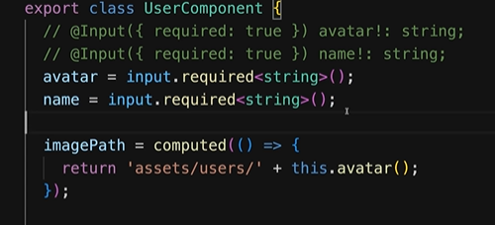

@Output is a decorator used in component communication to allow a child component to send data to its parent component. It works in conjunction with the EventEmitter class to emit custom events. This is particularly useful for creating reusable and modular components that can notify their parent components of certain events or state change

There are two ways for use output but call Output or output from Angular core and are different

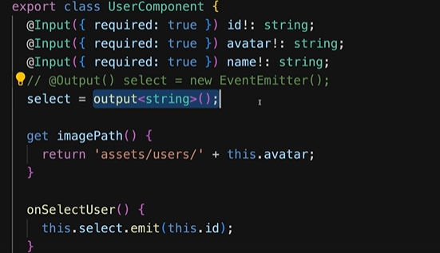

And to get the output from the parent component 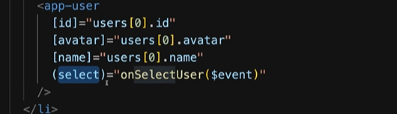

TypeScript notes :

! that mean variable will not be undefined

? this mean can be undefined if for example need to access to attr in variable object?.att that mean if object is undefined not access to attr

Loops in Angular

This is an example of loop data of user inside html code

Track is special thing that Angular need to save identifier of each element to make update in the table rendered if there any changes in the list without recreate all the list

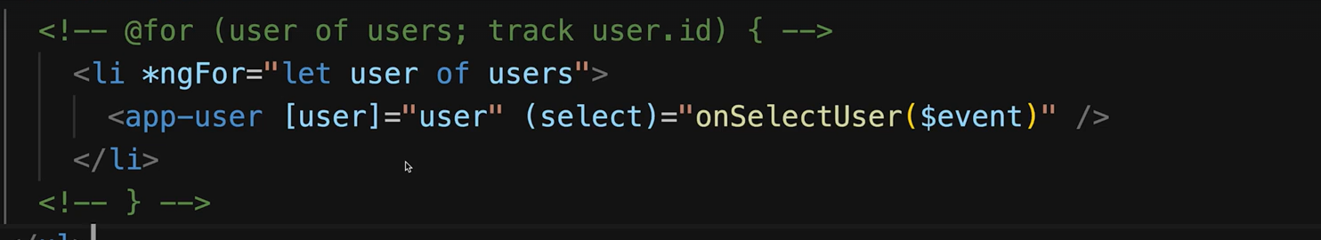

If condition in Angular

In some like loop we just need to add @If and here an example

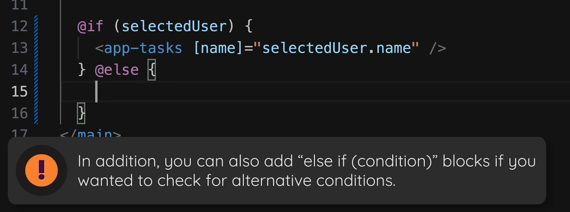

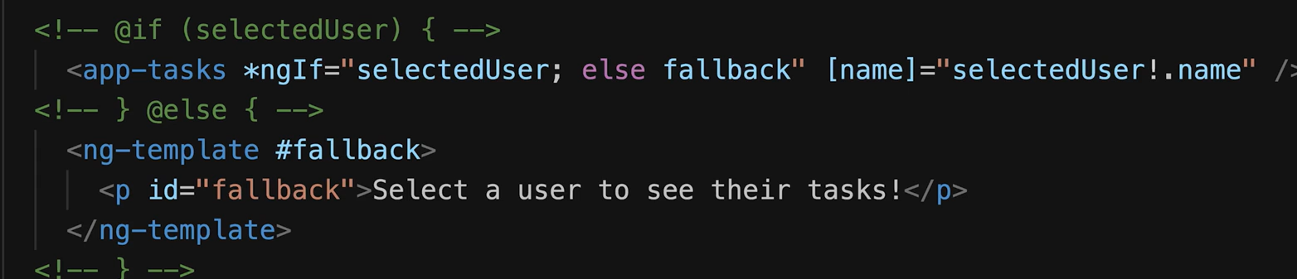

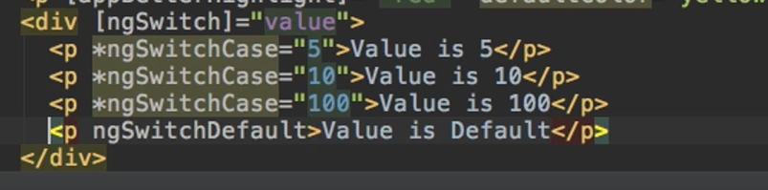

@if and @for just supported in angular 17

ngIf and ngFor are component should be added in imports

Two-Way-Binding is typically achieved using the [(ngModel)] directive. This directive combines both property binding and event binding. Property binding updates the view with the model's data, while event binding allows the view to update the model when the user interacts with the form elements (such as input fields).

Should add import { FormsModule } from '@angular/forms'; to angular recognize the ngModel directive

Work with signals with that way

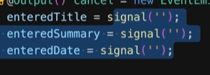

For template nothing change

<input [(ngModel)]="enteredTitle" placeholder=" entered Title ">

Note: components are a directives with template (HTML interface)

ng-content : this will be use to include what inside the selector markup let said we have user component and we need to use it inside other component template but in different way I mean

<app-user>

<h1>Header</h1>

Some code

</app-user>

In normal case what inside app-user will be deleted to keep that content inside we need to use ng-content in template of user like this

<div><ng-content/></div>

ng-content is used a lot if there are common templates or style that help in performing and write less code if that will be repeated a lot

Pipes: it means output transformer the output can be anything (html tag value, promise we use async pipe, can also add pip inside ngFor) there are many pipes provided by angular common like Date formats or we can create our pipes and that example how to use pipe



For create custom pipes like in this example



We need to create ourCustomPipe.pipe.ts ng g p ourCustomPipe

Use @Pipe and implement PipeTransform

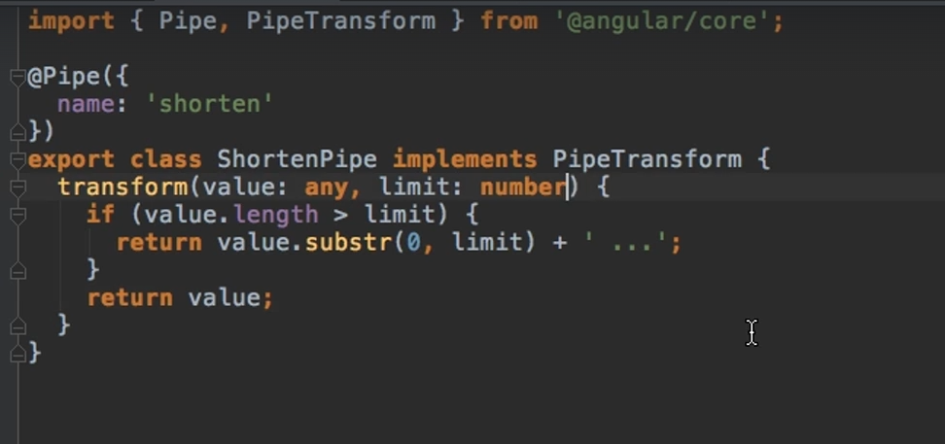

{{ value | pipe:arg}}

Dependency injection: is a design pattern used in Angular to create and manage the dependencies of a class. It allows a class to receive its dependencies from an external source rather than creating them itself, promoting loose coupling and making the code more modular, testable, and maintainable.

That good think about DI is we don’t need to initialize service and create instance each time on each component and also avoid problem of instance that don’t get changes happening on other components to implement DI we need just to add @Injectable in service like that 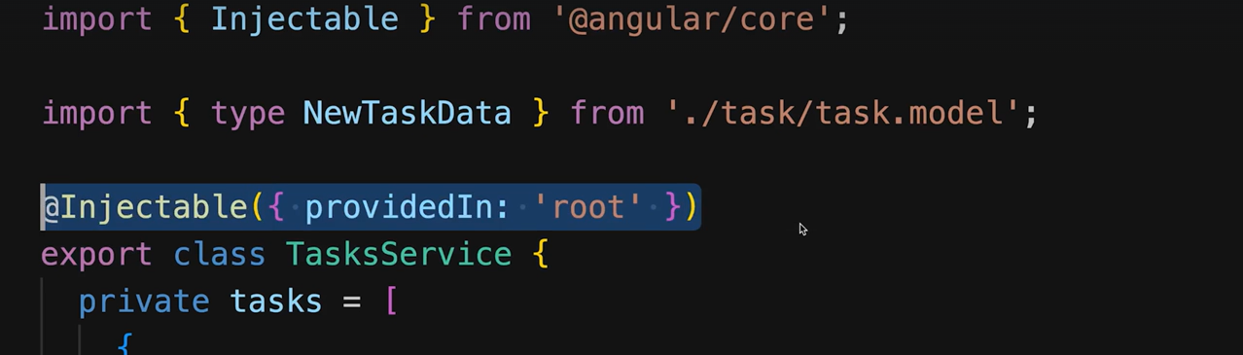

Then in the component we need to use contractor to do the injection in this way

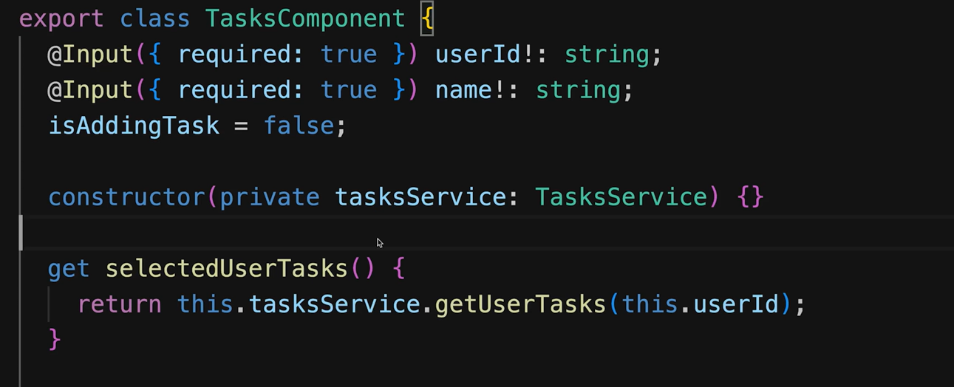

Or use this it better

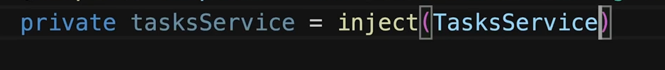

# Angular Modules

Before Angular 14 there were no “Standalone Component “, today Standalone Component are the recommended way of building components but we can also still use “ Module-based Component” with Angular Modules

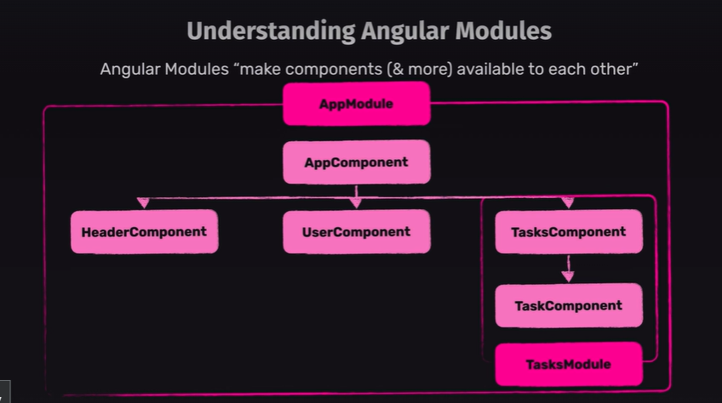

In Standalone Component we bootstrapping our App Component directly in main.ts using this script

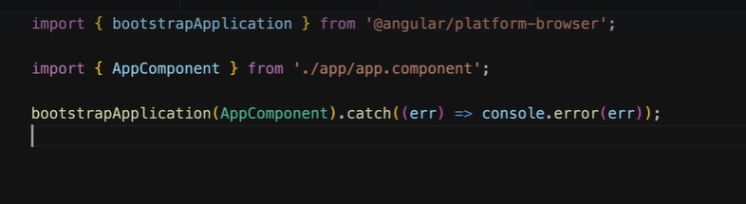

But in Angular Modules we need to use App Module instead and with different way

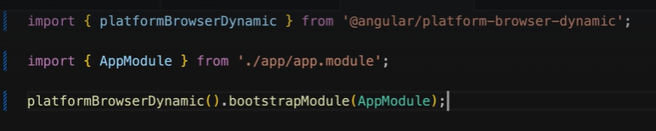

When use Angular Modules we need to create a class App module inside it will put our App component, but we need to remove anything related to standalone like standalone equal a true and remove imports part because in app module we will put all component related to App Component after changing all standalone component our App Modules should like this 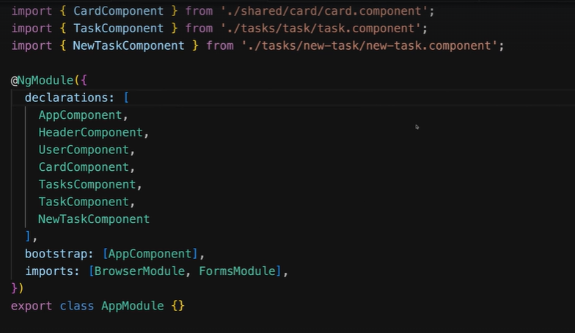in declaration we put all component we used and in bootstrap we put the root component and imports we should add Browser Module is necessary and it allow us use Pipes and also others Modules used like Form Module , if we have a big application it will be better to divide the application more apps module for each part of application and call it in our module inside imports like this example 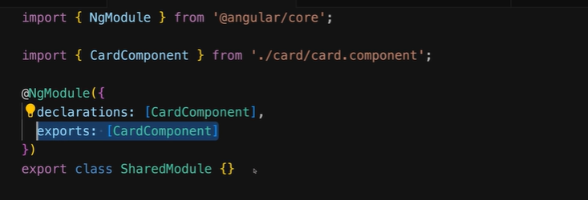

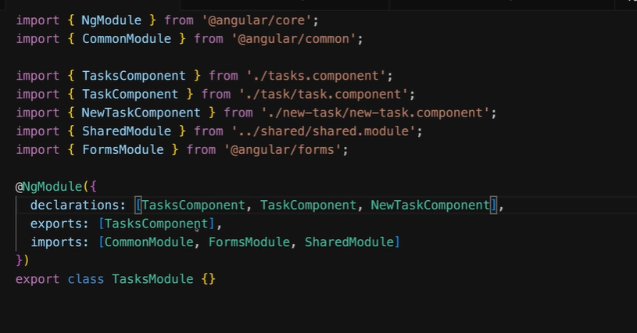

Common Modules that include Pipes if we are in child Module not app module

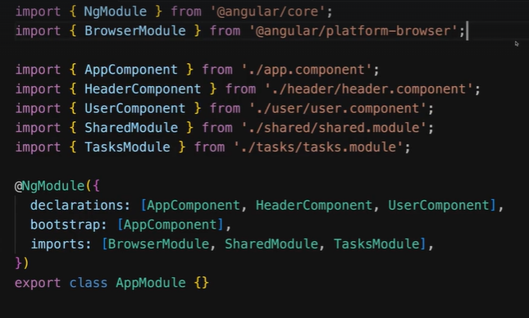Notes:

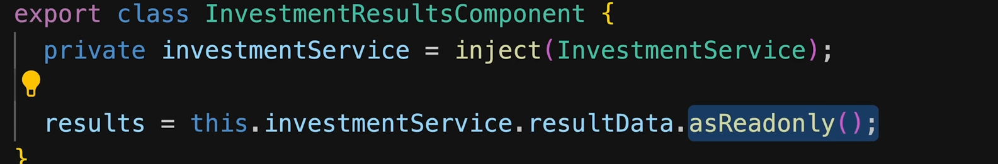

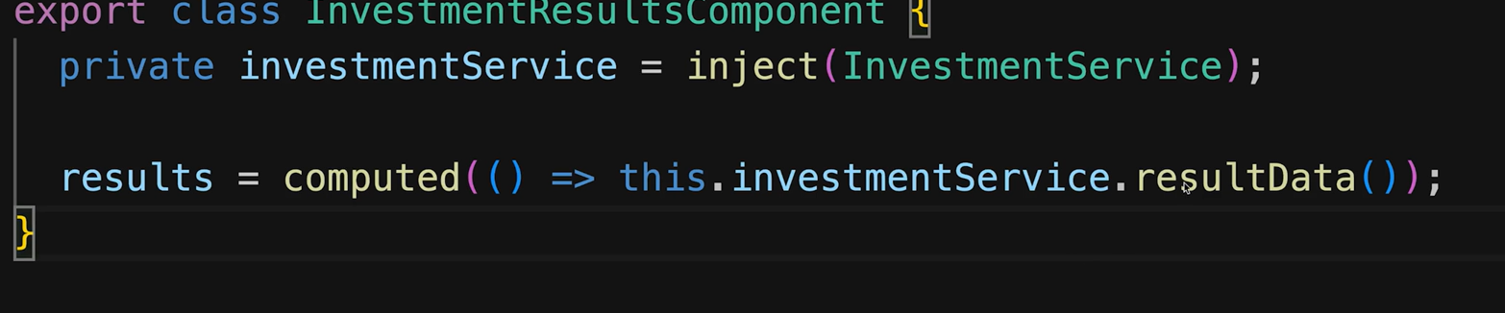

There are two why to put value of signal coming from service

# Directives:

Directives are a type of component that allow you to extend or modify the behavior of HTML elements. They provide a way to create reusable functionalities and apply them to elements in your application's templates. There are three types of directives in Angular:

**Component Directives**: These are the most common type of directives in Angular. Components are directives with a template. They are typically used to create reusable UI elements in your application.

**Attribute Directives:** These directives change the appearance or behavior of an element, component, or another directive. They are applied as attributes to HTML elements and are typically used for tasks such as styling elements, handling user input, or conditionally rendering elements.

**Structural Directives:** These directives change the DOM layout by adding, removing, or manipulating elements. They are responsible for altering the structure of the DOM based on conditions specified in your Angular templates. Examples include *ngIf, *ngFor, and *ngSwitch.

Example of Attribute directives :



In this example we create appBetterHighlight directive with two parameters for change background color I miss in this example to move this HostBinding into ngOnInit there many work to use it but what isn’t in comment is the best way , HostListener is responsible of check event and HostBinding to choose what you change

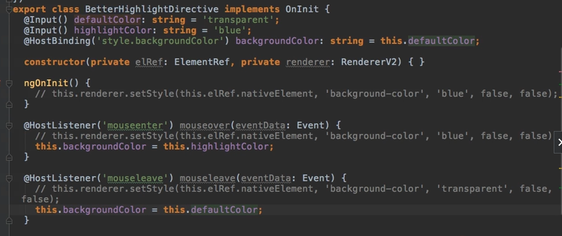

And for directives that start * called structural directive like *ngFor *ngIf for create a structural directive you need to do like this

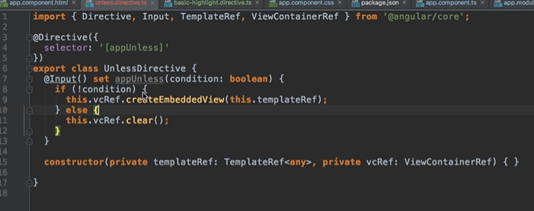

This input should have the same name of selector and structural directive (need more info check 186 udemy)

# Routing

Routing is one of important thing that should be apply to big app because we will have a lot of components and we need to navigate between those without touch SPA concept using Angular routes

We need to create an array type Routes and apply it using Router Module like the example bellow also some notes like in the links we need to add Router Link in HMTL code it better without / in beginning because will take your current link and add /user I mean if we are in calhost:4200/home routerLink = ‘user’ => localhost:4200/user routerLink = ‘/user’ => localhost:4200/home/user

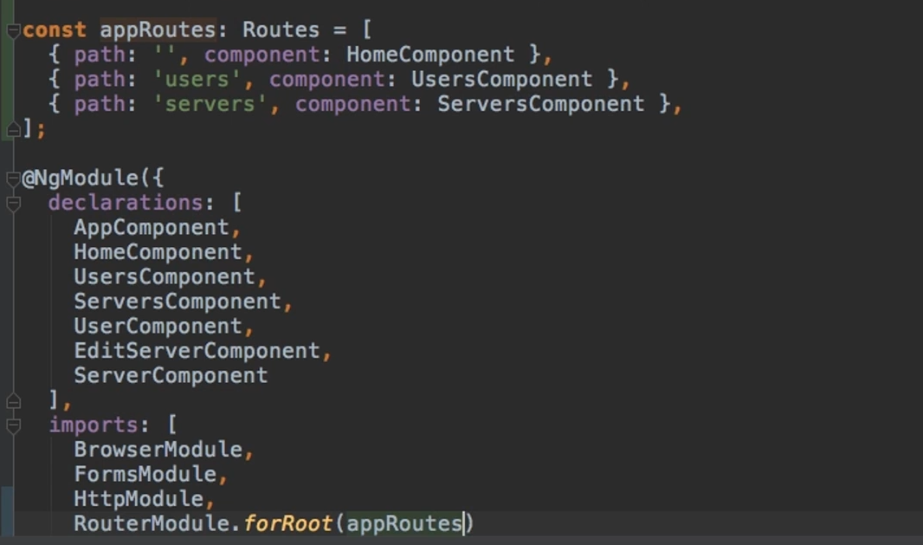

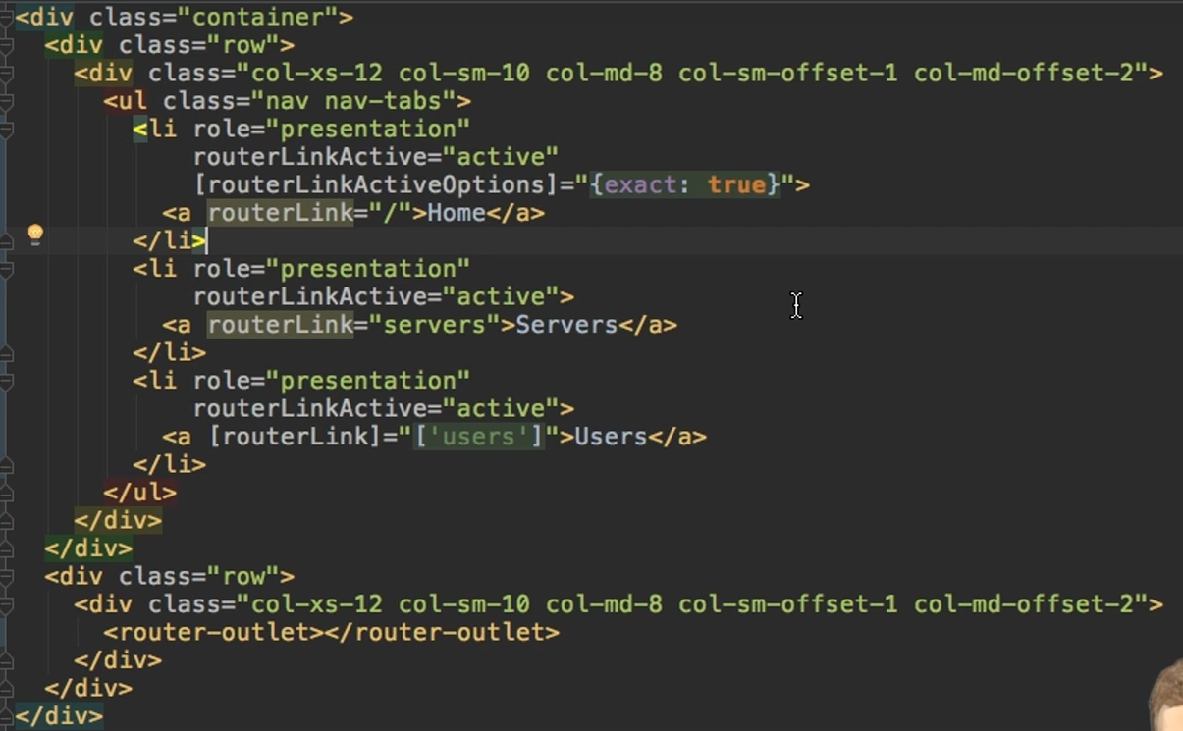

Router Link Active check if the path is in router Link is yes apply CSS class active we add router link active option with exact true to tell to angular the link should have only / because all others link will have / in the path that why if we don’t add it the home will be always active

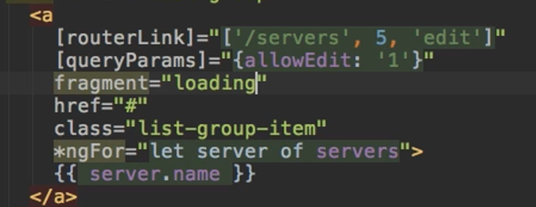

We put rout link like array to accept other parameters and query params is not a directive is part of angular routing that allow you to pass parameters to link

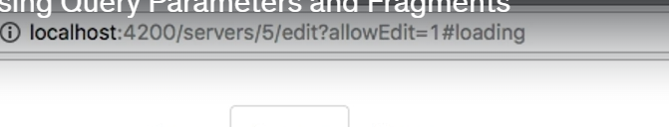

This the result if you click in the link



To pass parameters in route link we do like that in the result /users/10/Anna

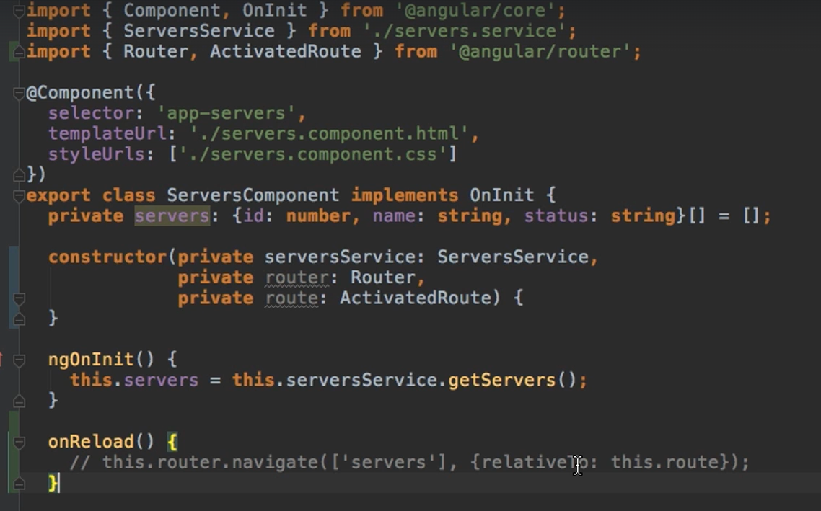

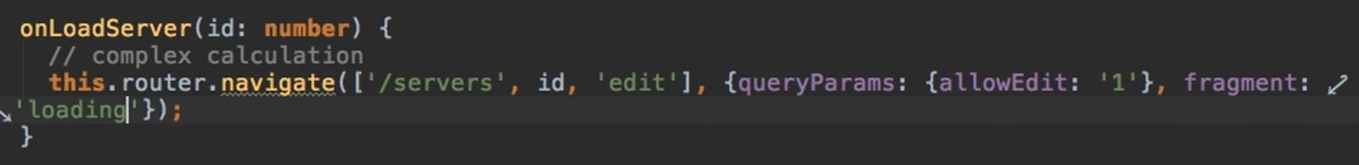

Also we can navigate in side ts component use router navigate like example in the top relativetTo we put path that we move from that mean link/servers activated route is give us the path that we are on it

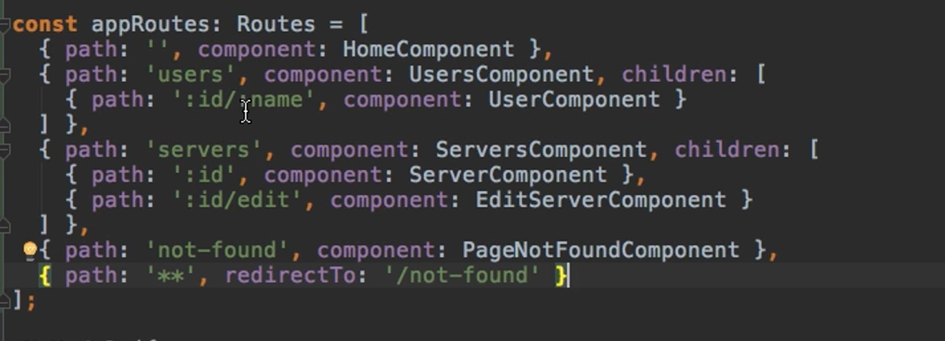

We can also pass parameters like this example for pass id and name and to get those parameters

And also pass children part that children should be apply in parent component by <router-outlet></router-outlet>

like this 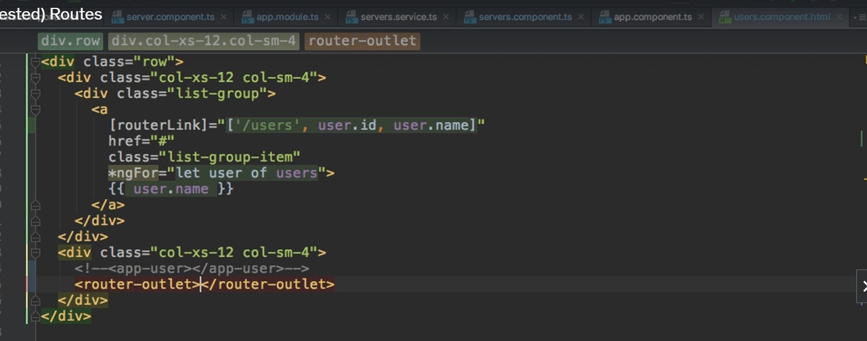

We need to use snapshot of parms of our activated route and use subscribe if there are any change in the route update the parameters again this needed if we need to call same component with different parameters from x/1 to x/2 if we don’t do this we will go to x/2 but data will stay of x/1

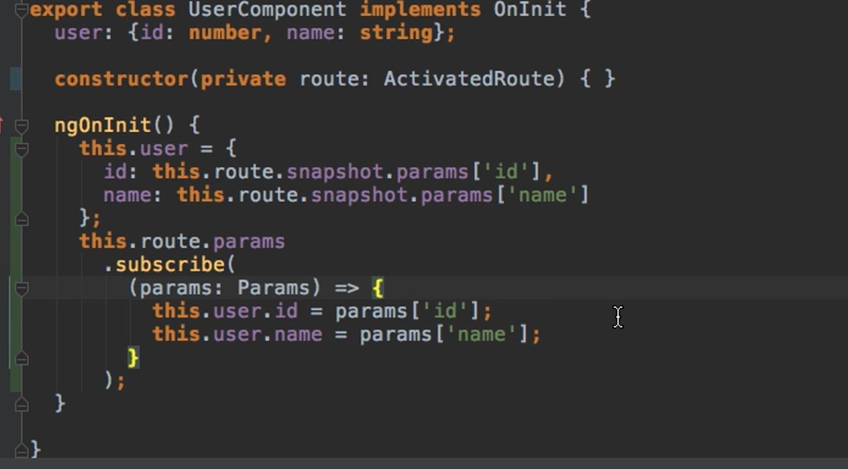

Guards: is to authenticate and authorized to navigate to a specific link

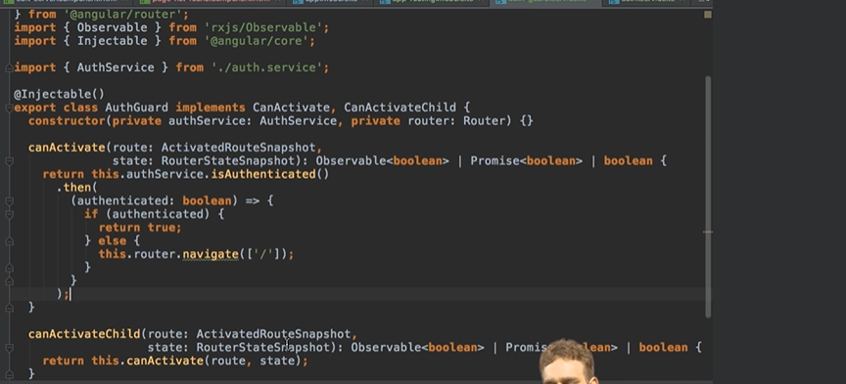

This service will always send you to root part when you are not logged

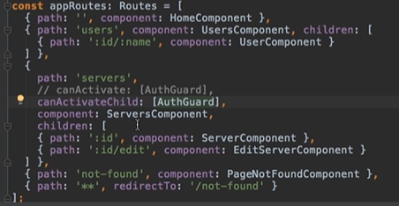

We need to can activate and each time you try to navigate to servers and you are not logged you will return to home component

Or you can activate child to do the same but with children

Auth guard should add to appModule

# Observables:

Observable is a powerful way to handle asynchronous operations and events. It is a part of the Reactive Extensions for JavaScript (RxJS) library, which is included with Angular. Observables provide support for passing messages between parts of your application.

Here’s a more detailed explanation:

### What is Observable?

An Observable is a data type that represents a stream of data. This data can be pushed to subscribers over time. Observables can handle events, HTTP requests, and other asynchronous data streams.

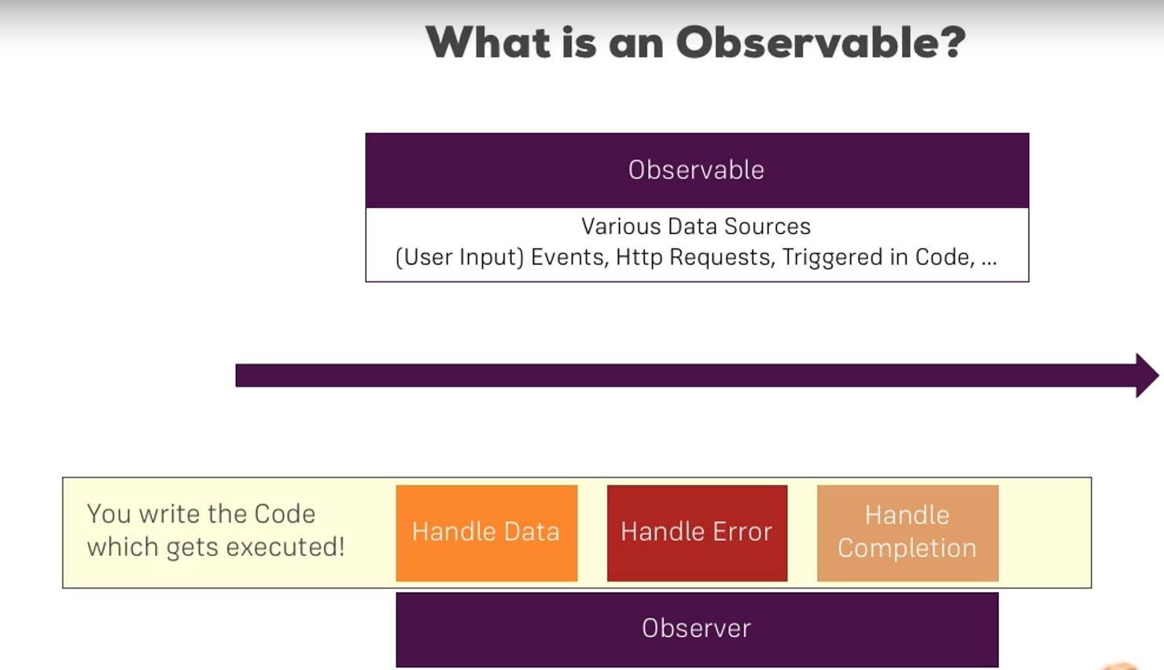

The operators in rxjs/operators are using to control data coming from observable to use it we need to call function pipe(operator1,operator2) operators in rxjs there are many like map and filter

???? need to learn more about operator like take and other

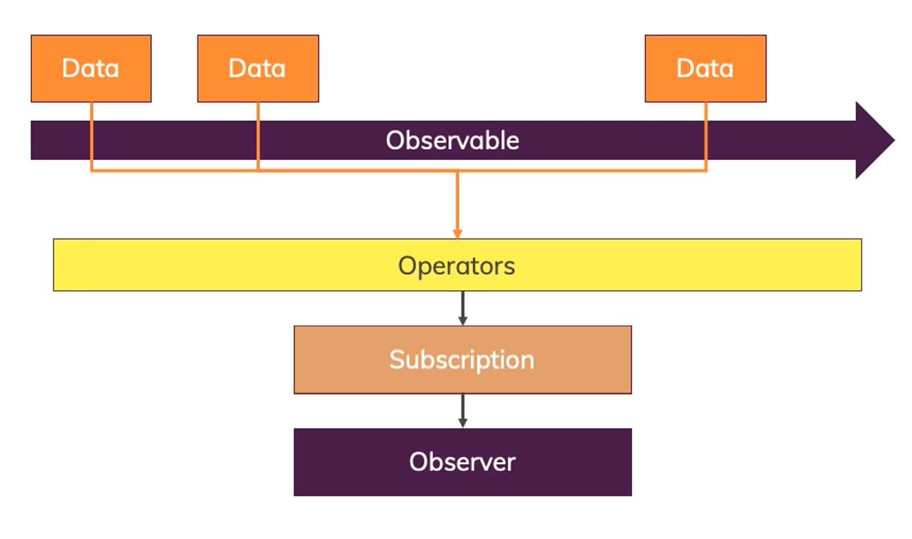

There is an example of it 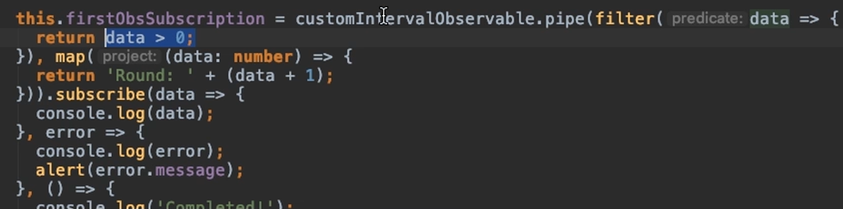

# Angular Forms:

There are two approach to work with forms

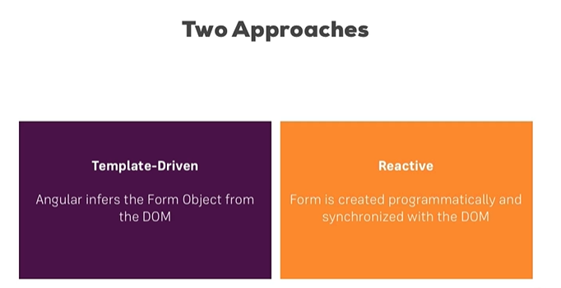

 template-driven forms:

You will need to add into app modules in imports formsModule to work with this approach

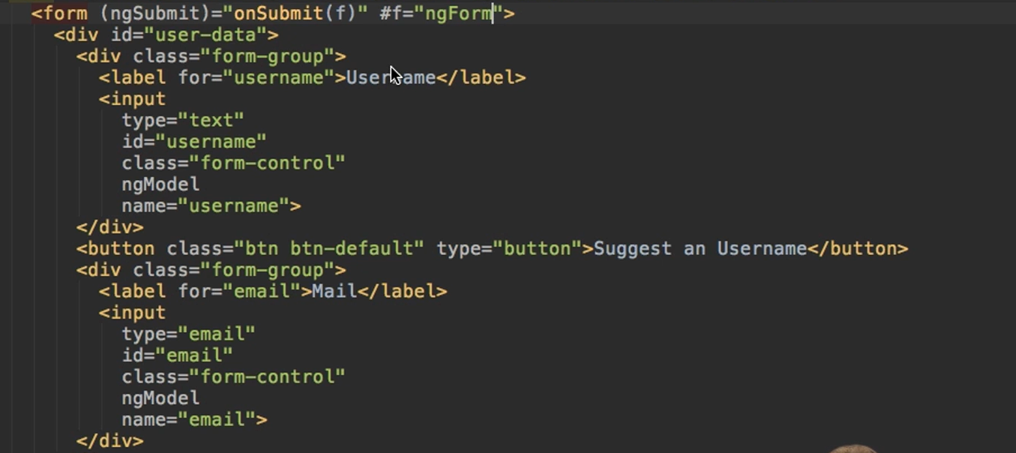

We need to have our form inside form tag also need to add ngForm into our ng submit that can give us access to values and others thing related to form like if is valid or not if we print f in console we will see this result

Dirty =>if form is change

Errors => show error that we had

Value => inside it we have values of our form

Valid and Invalid => is clear

Touched and untouched => is clear

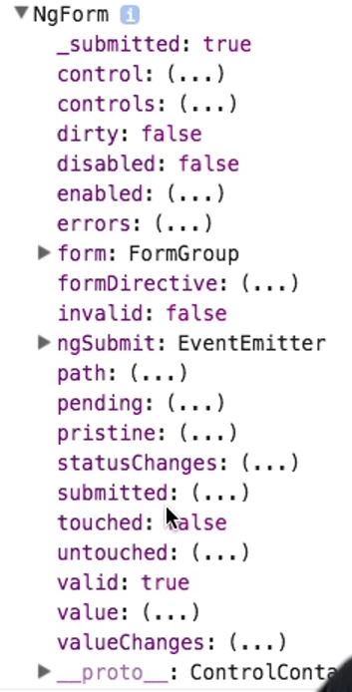

If we need to change into form in js we need to use one of two setValues or patchValue the first is use for change all data of form but other just attributes that you want to change like this example 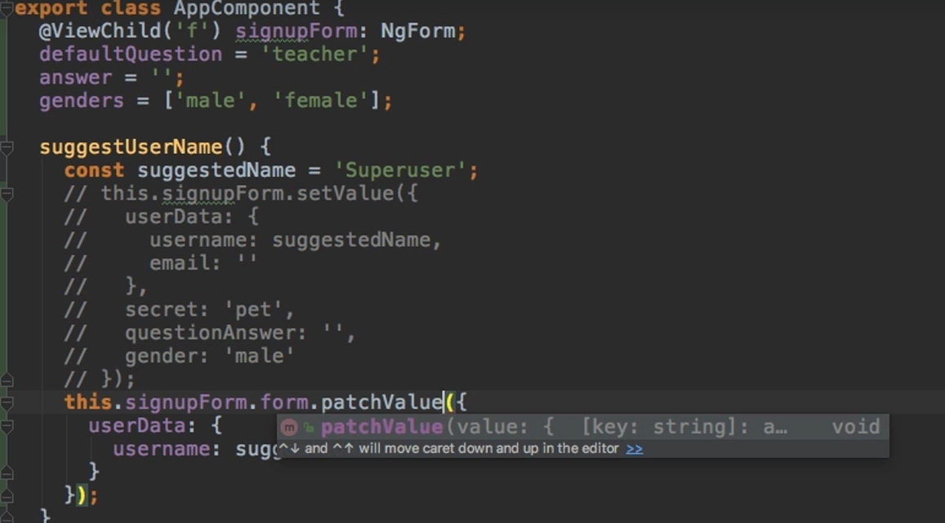

We can also reset the form use this.signupForm.reset()

Reactive approach:

You will need to add into app modules in imports ReactiveFormsModule to work with this approach

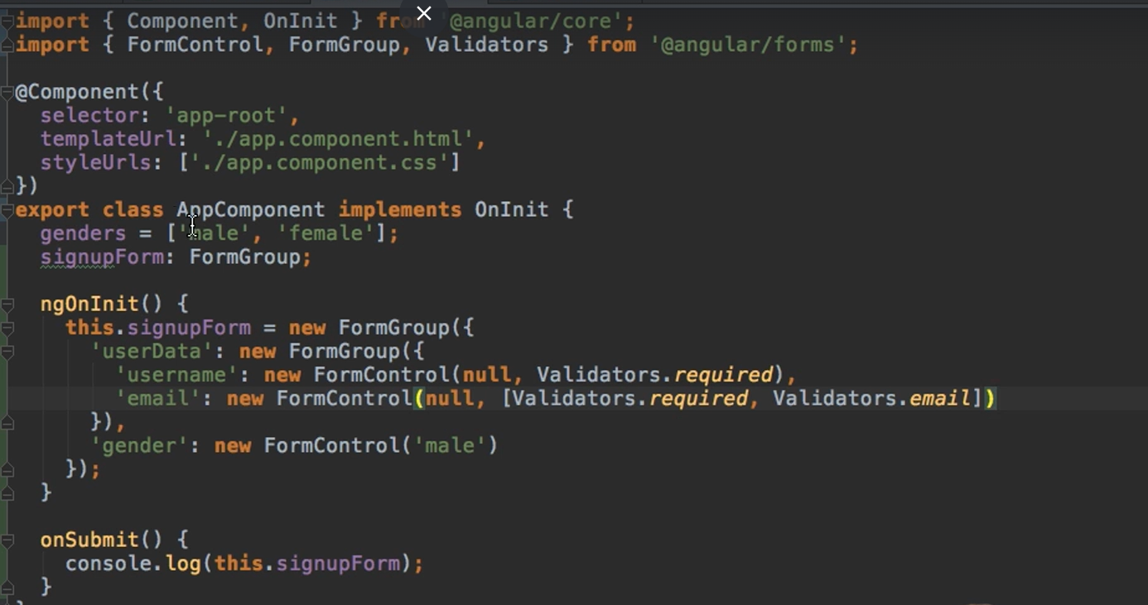

We need to start with creating form group and also required validation (can be a custom validation check video 530 or code ) before rendering html code then in HTML we need to add

[formGroup] into form tag and formControlName on each input

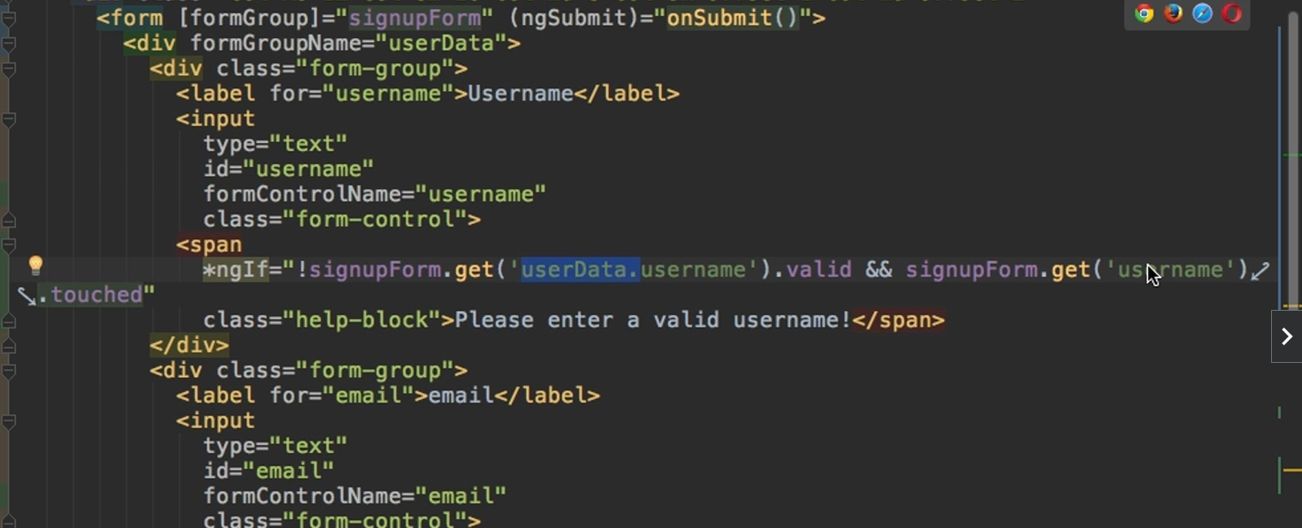

Note

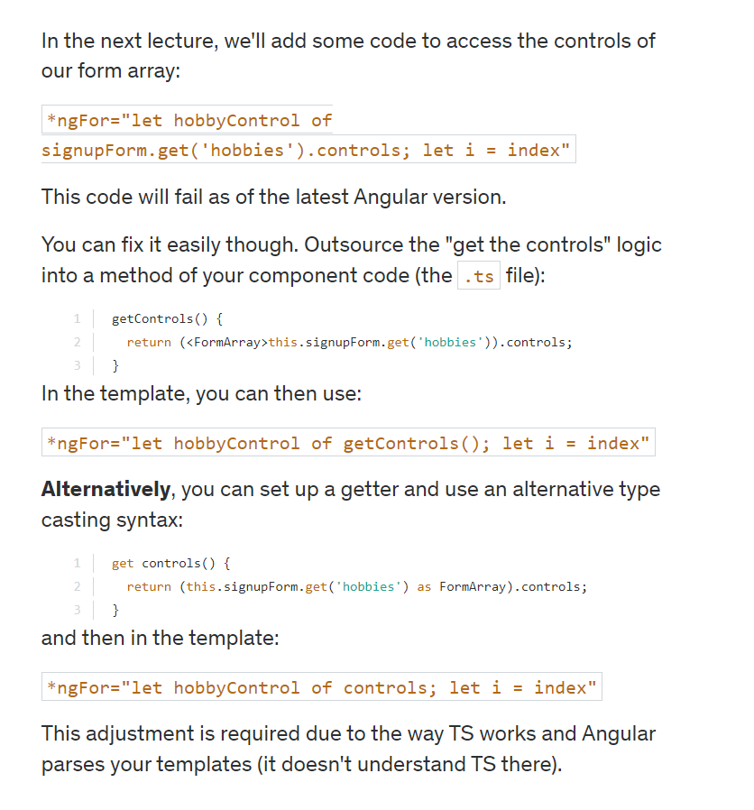

In reactive forms we can also use arrays

This will allow us to add form control dynamically

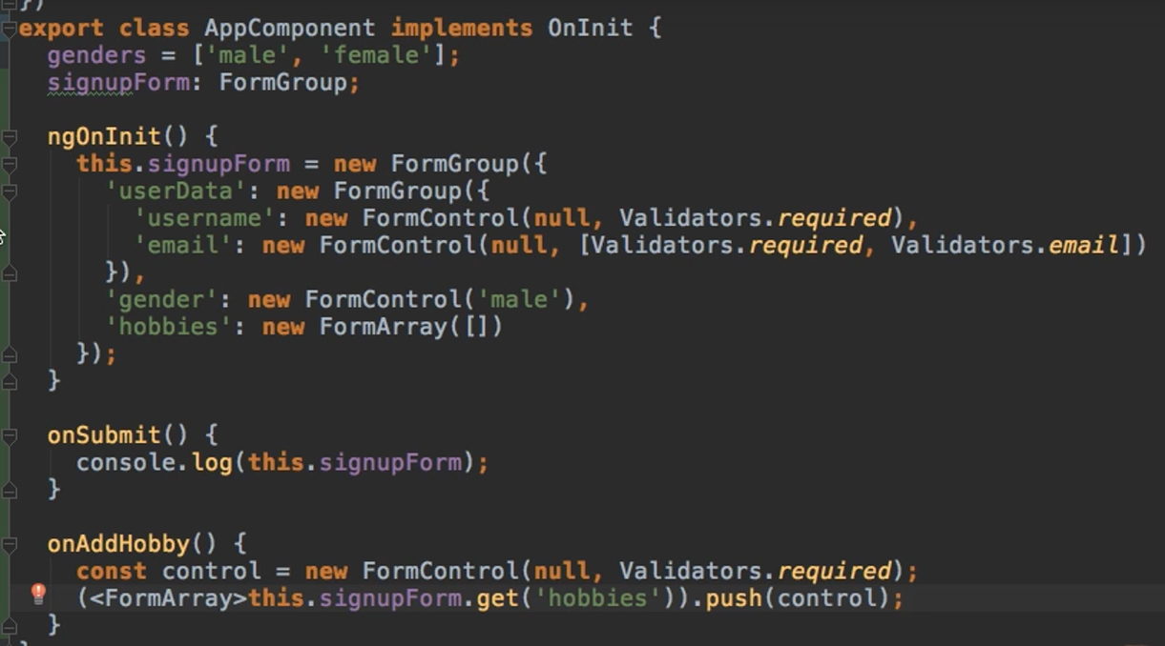

And to implement this we need to form group contain all form control that we will add

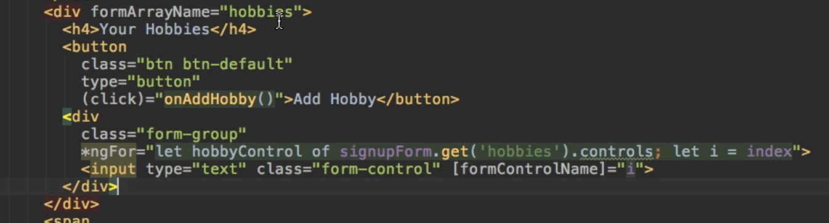

We can check errors in form to know which error should be appear

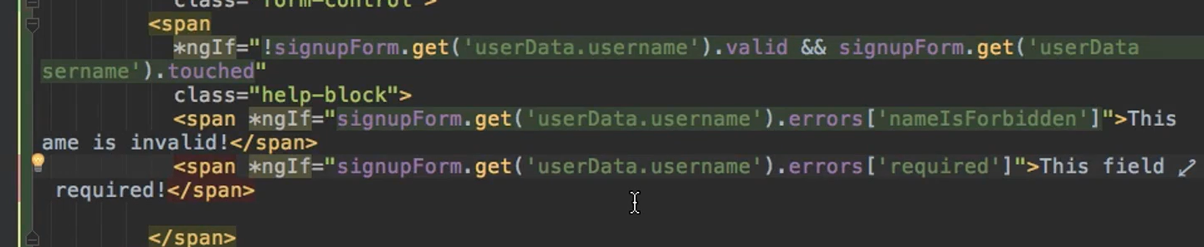

???? check code part that provide how to work with httpClientModule and authentication now different between interceptor and authGuard and normal service and how to use it with router

# Dynamic component (model pop up):

There two approaches for applying a dynamic component

Use *ngIf for show the model and integrate date with @Input or use other approach calling model in TS but we need first add <ng-template> in HTML then inside this tag we can apply any component we went

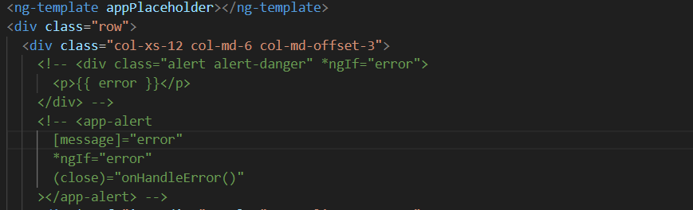

Commented line is the approach with *ngIf

When you use <ng-template> with a directive ‘appPlaceHolder’, you are typically creating a structural directive. Structural directives are responsible for shaping or reshaping the DOM's structure, typically by adding, removing, or manipulating elements

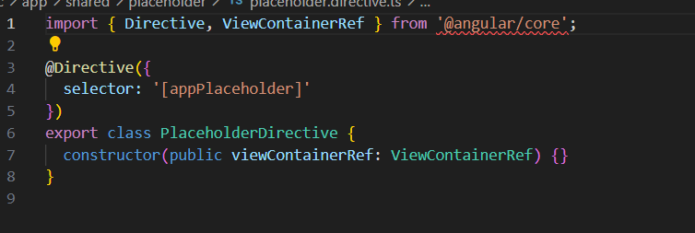

We need to create this directive and inject ViewContainerRef

ViewContainerRef is a core service in Angular that represents a container where one or more views can be attached. It's typically used in conjunction with structural directives and dynamic component loading. Here's a deeper dive into its usage and purpose:

Purpose of ViewContainerRef

**View Management**: It allows for adding, removing, and moving views within the container.

**Dynamic Component Loading**: It can be used to dynamically create and insert components into the view.

Common Methods

createEmbeddedView: Creates an embedded view from a TemplateRef and inserts it into the container.

clear: Clears all views from the container.

createComponent: Creates a new component and inserts it into the container.

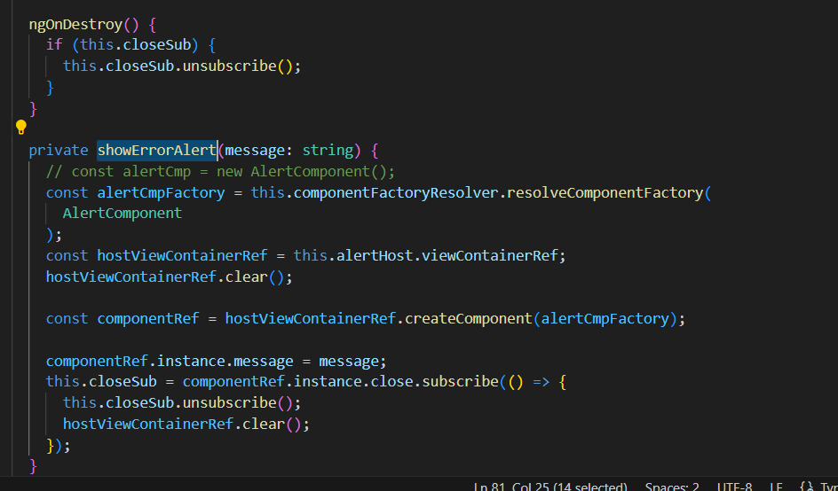

ComponentFactoryResolver is a service in Angular that is used to resolve a ComponentFactory for a given component. This factory can then be used to create instances of the component. It's particularly useful for dynamically loading components at runtime.

In this example we will call AlertComponent first we need to create an instance using ComponentFactoryResolver then we need to use directive that we create and call viewContainerRef



And use it to create component of alert also send to @input using instance and also use it to subscribe to the methods inside the alert component

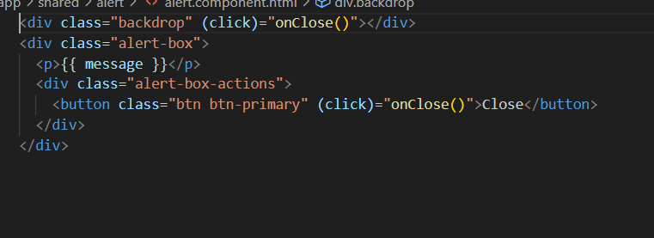

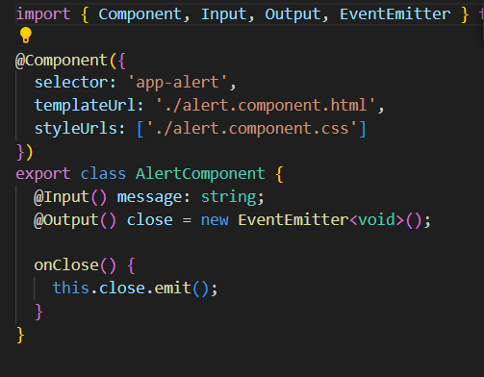

This an example of alert component

# Modules:

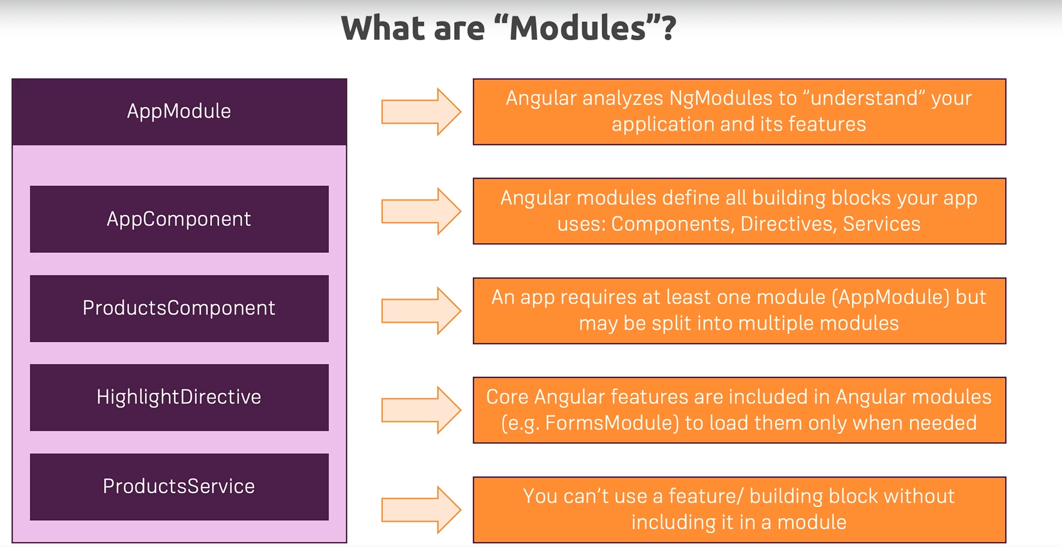

# NgRx:

NgRx is a state management solution for angular based in architecture below

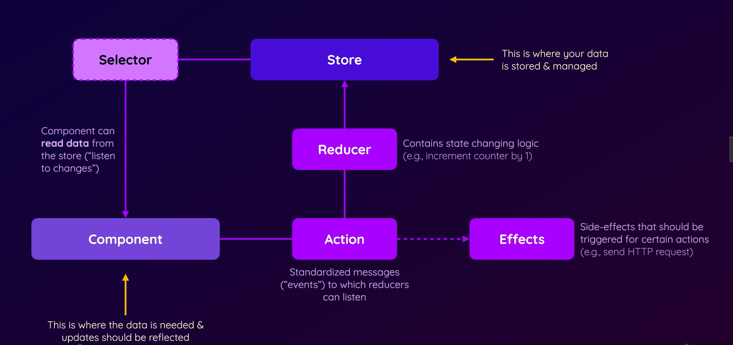

Ng add @ngrx/store

# Use i18n:

First we need to add ngx-translate dependency

npm install @ngx-translate/core @ngx-translate/http-loader –save

then create a service that load content of translators files

app-translate-loader.ts let call this file

import { TranslateLoader } from '@ngx-translate/core';

import { HttpClient } from '@angular/common/http';

import { Observable } from 'rxjs';

import { map } from 'rxjs/operators';

export class AppTranslateLoader implements TranslateLoader {

constructor(private http: HttpClient) {}

getTranslation(lang: string): Observable<any> {

return this.http.get(`/assets/i18n/${lang}.json`).pipe(

map((response: any) => response)

);

}

}

Then create those files en.json / fr.json

Then we need to add it to the providers: in AppComponent

import { Component } from '@angular/core';

import { TranslateModule, TranslateService, TranslateLoader } from '@ngx-translate/core';

import { HttpClient } from '@angular/common/http';

import { AppTranslateLoader } from './app-translate-loader';

import { provideHttpClient } from '@angular/common/http';

@Component({

selector: 'app-root',

standalone: true,

imports: [

TranslateModule

],

providers: [

provideHttpClient(),

{

provide: TranslateLoader,

useFactory: (http: HttpClient) => new AppTranslateLoader(http),

deps: [HttpClient]

},

TranslateService

],

template: `

<button (click)="changeLanguage('en')">{{ 'buttonLabel' | translate }}</button>

<button (click)="changeLanguage('fr')">{{ 'buttonLabel' | translate }}</button>

<h1>{{ 'homeTitle' | translate }}</h1>

`

})

export class AppComponent {

constructor(private translate: TranslateService) {

const savedLang = localStorage.getItem('lang') || 'en';

this.translate.setDefaultLang(savedLang);

this.translate.use(savedLang);

}

changeLanguage(lang: string) {

this.translate.use(lang);

localStorage.setItem('lang', lang);

}

}